Jahangirnagar University
Institute of Information Technology
Savar, Dhaka-1342

Project report
over
XYZ Company-Savar Branch Network Design

Course: Computer Networks Lab
Course Code: ICT-3104

Submitted To
Jesmin Akhter, PhD
Professor, Institute of Information Technology
Submitted By
Md. Shaon Khan
ID: 1984
Session: 2022–2023

Date of Submission
7 May 2026

TABLE OF CONTENTS
Contents
1. INTRODUCTION 4
2. PROJECT OBJECTIVES 5
3. NETWORK REQUIREMENTS 5
4. NETWORK TOPOLOGY 6
5. IP ADDRESSING AND VLAN PLAN 7
6. DEVICE AND PORT CONNECTION PLAN 8
7. PHYSICAL CABLING 8
8. SWITCH CONFIGURATION 8
8.1 Enter Configuration Mode 8
8.2 Create VLANs 9
8.3 Configure Router Link as Trunk 9
8.4 Configure Admin/IT Access Ports 9
8.5 Configure Finance/HR Access Ports 9
8.6 Configure Customer Service Access Ports 9
8.7 Configure Access Point Ports 10
8.8 Save Configuration 10
9. SWITCH VERIFICATION 10
10. ROUTER-ON-A-STICK CONFIGURATION 11
10.1 Enable Physical Interface 11
10.2 VLAN 10 Subinterface 11
10.3 VLAN 20 Subinterface 11
10.4 VLAN 30 Subinterface 12
10.5 Native VLAN 99 Subinterface 12
11. DHCP CONFIGURATION 12
11.1 Excluded Addresses 12
11.2 Admin/IT DHCP 12
11.3 Finance/HR DHCP 12
11.4 Customer Service DHCP 12
11.5 Save Configuration 13
12. WIRELESS ACCESS POINT CONFIGURATION 13
13. CLIENT CONFIGURATION 14
13.1 Wired Clients 14
13.2 Wireless Clients 14
14. DHCP VERIFICATION 14
15. ROUTER INTERFACE VERIFICATION 15
16. NETWORK TESTING 15
16.1 Router to VLAN Gateways 15
16.2 Router to Wireless Client 15
17. INTER-VLAN ROUTING VERIFICATION 15
18. FINAL VERIFICATION SUMMARY 17
19. SECURITY CONSIDERATIONS 17
20. TROUBLESHOOTING AND RESOLUTION 17
21. CONCLUSION 18
22. REFERENCES 18
APPENDIX A: COMPLETE SWITCH CONFIGURATION 18
APPENDIX B: COMPLETE FINAL ROUTER CONFIGURATION 19
APPENDIX C: VERIFICATION COMMANDS 21
Switch 21
Router 21
Client 21

1. INTRODUCTION
This project presents the design and implementation of a computer network for the Savar branch of XYZ Company using Cisco Packet Tracer. The purpose of the project is to build a structured, department-wise network that allows employees of different departments to communicate efficiently while keeping their traffic logically separated for better organization and control.
A company branch with multiple departments requires a structured network rather than a flat network because a flat network mixes broadcast traffic from all departments together, which increases congestion and makes management difficult. A structured network divides the organization into logical groups so that each department has its own broadcast domain and can be managed independently.
Virtual Local Area Networks (VLANs) are used in this project to separate the Admin/IT, Finance/HR and Customer Service departments at Layer 2, even though all departments share the same physical switch. VLANs reduce unnecessary broadcast traffic and provide a basic level of traffic isolation between departments.
Since each VLAN is a separate broadcast domain, devices in different VLANs cannot communicate with each other without a routing function. Inter-VLAN communication is therefore required so that, for example, the Finance/HR department can exchange data with the Customer Service department when necessary. This project uses the Router-on-a-Stick method to achieve inter-VLAN routing using a single router interface with subinterfaces.
Dynamic Host Configuration Protocol (DHCP) is used so that end devices automatically receive an IP address, subnet mask, default gateway and DNS server address without manual configuration on each device. This reduces administrative effort and configuration errors, especially as the number of devices increases.
Wireless connectivity is also included in the design because modern offices require mobility for staff who use laptops. Each department is provided with its own wireless access point and SSID so that wireless clients join the correct VLAN based on the department they belong to.
Cisco Packet Tracer is used as the simulation platform for this project. It allows routers, switches, access points, PCs and laptops to be configured and tested in a virtual environment before actual deployment, which makes it a suitable tool for academic networking projects.

2. PROJECT OBJECTIVES
The main objectives of this project are as follows:
1. Design a network for XYZ Company's Savar branch.
2. Divide departments into separate VLANs.
3. Provide wired and wireless connectivity.
4. Configure DHCP for automatic IP assignment.
5. Configure Router-on-a-Stick for inter-VLAN routing.
6. Configure trunk communication between router and switch.
7. Provide wireless access for each department.
8. Verify communication between different departments.
9. Test the final network using Cisco Packet Tracer.

3. NETWORK REQUIREMENTS
Table 1 summarizes the requirements of the project and how each requirement was implemented.
Requirement | Implementation
Router | One Cisco Router 2911 (R-SAVAR)
Layer 2 Switch | One Cisco Switch 2960 (SW-SAVAR)
Access Points | Three access points (AP1, AP2, AP3)
Wired PCs | Six PCs (PC0–PC5)
Wireless Laptops | Three laptops (Laptop0–Laptop2)
Department VLANs | Three VLANs: Admin/IT, Finance/HR, Customer Service
Management/Native VLAN | One native VLAN (VLAN 99)
DHCP | Configured on R-SAVAR for all department VLANs
Router-on-a-Stick | Configured on R-SAVAR using subinterfaces
Inter-VLAN Communication | Achieved through router subinterfaces
Wireless Security | WPA2-PSK on each access point

4. NETWORK TOPOLOGY
Figure 1 shows the logical layout of the network, illustrating how the router, switch, switches connecting each access point, wired PCs and wireless laptops are interconnected.
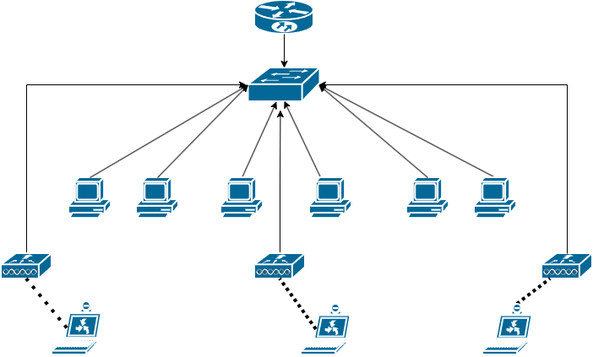
Figure 1: Logical Network Diagram of the XYZ Company Savar Branch Network
The network topology of the XYZ Company Savar branch, as implemented in Cisco Packet Tracer, is shown in Figure 2. The topology was built and tested in Cisco Packet Tracer.
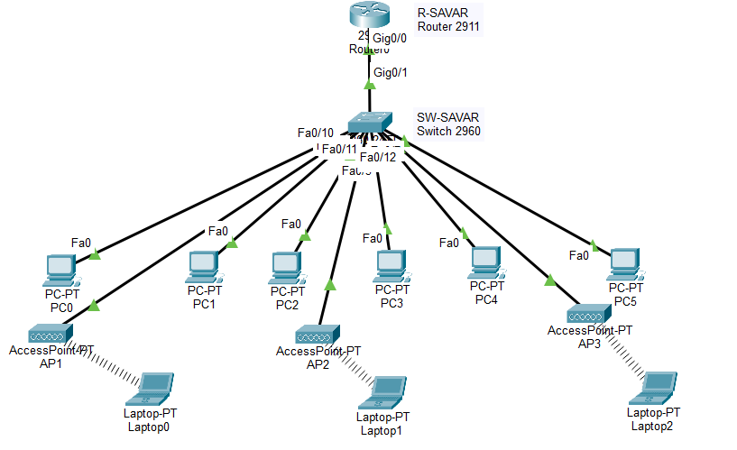
Figure 2: Complete XYZ Company Savar Branch Network Topology
The topology consists of one router, R-SAVAR (Cisco Router 2911), connected through its Gi0/0 interface to the Gi0/1 interface of the Layer 2 switch, SW-SAVAR (Cisco Switch 2960). The router-to-switch link is configured as a trunk so that it can carry traffic for multiple VLANs on a single physical link.
Three wireless access points are connected to the switch: AP1 serves the Admin/IT department, AP2 serves the Finance/HR department, and AP3 serves the Customer Service department. Each access point is connected to a switch port that belongs to the VLAN of its respective department.
Wired clients PC0 and PC1 belong to the Admin/IT department, PC2 and PC3 belong to the Finance/HR department, and PC4 and PC5 belong to the Customer Service department. Wireless clients Laptop0, Laptop1 and Laptop2 connect through AP1, AP2 and AP3 respectively, placing them in the Admin/IT, Finance/HR and Customer Service VLANs.

5. IP ADDRESSING AND VLAN PLAN
The base network assigned to the Savar branch is 192.168.1.0/24. This network is divided into four /26 subnets so that each department, along with the management/native VLAN, receives its own subnet.
The subnet mask used for each subnet is 255.255.255.192, which provides 62 usable host addresses per subnet. This is sufficient for the number of devices in each department while keeping the addressing plan simple.
Table 2 shows the complete IP addressing and VLAN plan used in this project.
Department | VLAN ID | VLAN Name | Network | Usable Host Range | Gateway
Admin/IT | 10 | ADMIN_IT | 192.168.1.0/26 | 192.168.1.1–192.168.1.62 | 192.168.1.1
Finance/HR | 20 | FINANCE_HR | 192.168.1.64/26 | 192.168.1.65–192.168.1.126 | 192.168.1.65
Customer Service/Reception | 30 | CUSTSERVICE | 192.168.1.128/26 | 192.168.1.129–192.168.1.190 | 192.168.1.129
Management/Native | 99 | MGMT_NATIVE | 192.168.1.192/26 | 192.168.1.193–192.168.1.254 | 192.168.1.193
Separate VLANs are used for each department so that broadcast traffic generated within one department does not affect the other departments. VLANs also allow different security and access policies to be applied to each department if required in the future, and they make the network easier to manage and troubleshoot as the company grows.

6. DEVICE AND PORT CONNECTION PLAN
Table 3 lists the switch port assignments for every device in the network.
Device | Switch Port | VLAN | Purpose
PC0 | Fa0/2 | 10 | Admin/IT
PC1 | Fa0/3 | 10 | Admin/IT
PC2 | Fa0/4 | 20 | Finance/HR
PC3 | Fa0/5 | 20 | Finance/HR
PC4 | Fa0/6 | 30 | Customer Service
PC5 | Fa0/7 | 30 | Customer Service
AP1 | Fa0/10 | 10 | Admin/IT Wi-Fi
AP2 | Fa0/11 | 20 | Finance/HR Wi-Fi
AP3 | Fa0/12 | 30 | Customer Service Wi-Fi
R-SAVAR | Gi0/0 ↔ SW-SAVAR Gi0/1 | Trunk | Router-on-a-Stick
The link between the router and the switch is configured as a trunk port because it must carry tagged traffic for all four VLANs. All other ports connecting end devices and access points are configured as access ports, since each of these devices belongs to only one VLAN.

7. PHYSICAL CABLING
All connections in this project use Copper Straight-Through cables, which is the correct cable type recommended by Cisco Packet Tracer for the following connections:
- Router Gi0/0 to Switch Gi0/1 – carries trunk traffic between the router and the switch.
- PC to Switch – connects each wired PC to its assigned access port.
- Access Point to Switch – connects each access point to its assigned access port.
The physical layout of these connections is visible in the topology diagram shown earlier in Figure 2.

8. SWITCH CONFIGURATION
This section explains the configuration of the switch SW-SAVAR step by step.

8.1 Enter Configuration Mode
enable
configure terminal
hostname SW-SAVAR

8.2 Create VLANs
vlan 10
name ADMIN_IT
exit

vlan 20
name FINANCE_HR
exit

vlan 30
name CUSTSERVICE
exit

vlan 99
name MGMT_NATIVE
exit
VLAN 10 (ADMIN_IT) is used for the Admin/IT department, VLAN 20 (FINANCE_HR) for the Finance/HR department, VLAN 30 (CUSTSERVICE) for the Customer Service department, and VLAN 99 (MGMT_NATIVE) is used as the native/management VLAN for the trunk link.

8.3 Configure Router Link as Trunk
interface gigabitEthernet 0/1
switchport mode trunk
switchport trunk native vlan 99
exit
Interface Gi0/1 connects the switch to the router and is configured as a trunk port so that it can carry traffic for multiple VLANs. VLAN 99 is set as the native VLAN for this trunk.

8.4 Configure Admin/IT Access Ports
interface range fastEthernet 0/2 - 3
switchport mode access
switchport access vlan 10
exit

8.5 Configure Finance/HR Access Ports
interface range fastEthernet 0/4 - 5
switchport mode access
switchport access vlan 20
exit

8.6 Configure Customer Service Access Ports
interface range fastEthernet 0/6 - 7
switchport mode access
switchport access vlan 30
exit

8.7 Configure Access Point Ports
AP1:
interface fastEthernet 0/10
switchport mode access
switchport access vlan 10
exit
AP2:
interface fastEthernet 0/11
switchport mode access
switchport access vlan 20
exit
AP3:
interface fastEthernet 0/12
switchport mode access
switchport access vlan 30
exit

8.8 Save Configuration
end
copy running-config startup-config

9. SWITCH VERIFICATION
The command show vlan brief was used to verify VLAN creation and port assignment on SW-SAVAR. The actual output is shown in Figure 3.
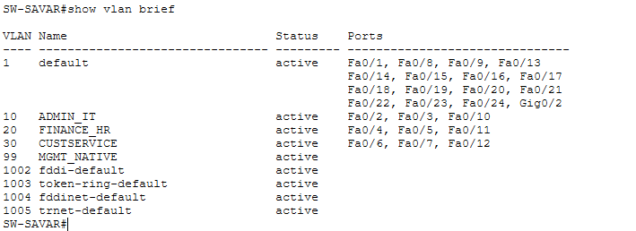
Figure 3: VLAN configuration and port assignments on SW-SAVAR.
The output confirms that VLAN 10 (ADMIN_IT) includes ports Fa0/2, Fa0/3 and Fa0/10; VLAN 20 (FINANCE_HR) includes ports Fa0/4, Fa0/5 and Fa0/11; VLAN 30 (CUSTSERVICE) includes ports Fa0/6, Fa0/7 and Fa0/12; and VLAN 99 (MGMT_NATIVE) is active on the switch.
The command show interfaces trunk was then used to verify the trunk link between the switch and the router. The actual output is shown in Figure 4.
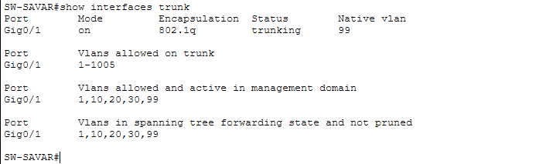
Figure 4: Trunk configuration of SW-SAVAR.
The output confirms that interface Gi0/1 is operating in 802.1Q trunking mode with a native VLAN of 99, and that VLANs 10, 20, 30 and 99 are allowed and active on the trunk.

10. ROUTER-ON-A-STICK CONFIGURATION
Router-on-a-Stick allows a single physical router interface to route traffic between multiple VLANs by creating logical subinterfaces, each associated with a specific VLAN through 802.1Q encapsulation. In this project, the physical interface Gi0/0 of R-SAVAR connects to the trunk port of the switch, and four subinterfaces are created under it.

10.1 Enable Physical Interface
enable
configure terminal
hostname R-SAVAR

interface gigabitEthernet 0/0
no shutdown
exit

10.2 VLAN 10 Subinterface
interface gigabitEthernet 0/0.10
encapsulation dot1Q 10
ip address 192.168.1.1 255.255.255.192
exit

10.3 VLAN 20 Subinterface
interface gigabitEthernet 0/0.20
encapsulation dot1Q 20
ip address 192.168.1.65 255.255.255.192
exit

10.4 VLAN 30 Subinterface
interface gigabitEthernet 0/0.30
encapsulation dot1Q 30
ip address 192.168.1.129 255.255.255.192
exit

10.5 Native VLAN 99 Subinterface
interface gigabitEthernet 0/0.99
encapsulation dot1Q 99 native
ip address 192.168.1.193 255.255.255.192
exit
Each subinterface acts as the default gateway for the devices in its corresponding VLAN, allowing traffic from one VLAN to be routed to another through R-SAVAR.

11. DHCP CONFIGURATION
The router R-SAVAR is configured to provide automatic IP addresses to client devices in each department VLAN using DHCP pools.

11.1 Excluded Addresses
ip dhcp excluded-address 192.168.1.1 192.168.1.10
ip dhcp excluded-address 192.168.1.65 192.168.1.75
ip dhcp excluded-address 192.168.1.129 192.168.1.139
These commands exclude the gateway addresses and a reserved range in each subnet from automatic assignment by DHCP.

11.2 Admin/IT DHCP
ip dhcp pool ADMIN_IT_POOL
network 192.168.1.0 255.255.255.192
default-router 192.168.1.1
dns-server 8.8.8.8
exit

11.3 Finance/HR DHCP
ip dhcp pool FINANCE_HR_POOL
network 192.168.1.64 255.255.255.192
default-router 192.168.1.65
dns-server 8.8.8.8
exit

11.4 Customer Service DHCP
ip dhcp pool CUSTSERVICE_POOL
network 192.168.1.128 255.255.255.192
default-router 192.168.1.129
dns-server 8.8.8.8
exit

11.5 Save Configuration
end
copy running-config startup-config

12. WIRELESS ACCESS POINT CONFIGURATION
Each access point is connected to a switch access port that belongs to the VLAN of its department, as summarized in Table 4.
Access Point | Switch Port | VLAN | SSID | Security
AP1 | Fa0/10 | 10 | ADMIN_IT_WIFI | WPA2-PSK
AP2 | Fa0/11 | 20 | FINANCE_HR_WIFI | WPA2-PSK
AP3 | Fa0/12 | 30 | CUSTSERVICE_WIFI | WPA2-PSK
AP1 is configured with SSID ADMIN_IT_WIFI and WPA2-PSK security for the Admin/IT department. The configuration screen is shown in Figure 5.
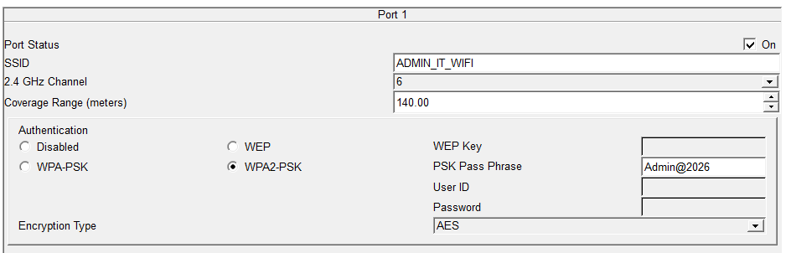
Figure 5: Wireless configuration of AP1 (ADMIN_IT_WIFI).
AP2 is configured with SSID FINANCE_HR_WIFI and WPA2-PSK security for the Finance/HR department. The configuration screen is shown in Figure 6.
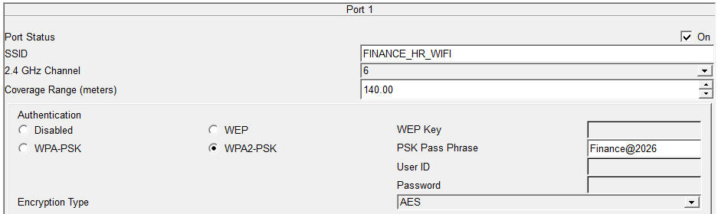
Figure 6: Wireless configuration of AP2 (FINANCE_HR_WIFI).
AP3 is configured with SSID CUSTSERVICE_WIFI and WPA2-PSK security for the Customer Service department. The configuration screen is shown in Figure 7.
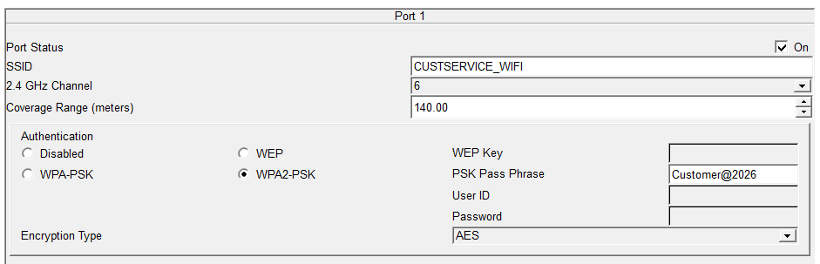
Figure 7: Wireless configuration of AP3 (CUSTSERVICE_WIFI).

13. CLIENT CONFIGURATION

13.1 Wired Clients
For each wired PC, the IP configuration was set through PC > Desktop > IP Configuration > DHCP. Once DHCP is selected, the PC automatically receives an IP address, subnet mask, default gateway and DNS server from the router.

13.2 Wireless Clients
For each wireless laptop, the following steps were performed: Laptop > Desktop > PC Wireless > Connect, then the appropriate SSID was selected, the WPA2 password was entered, and the IP configuration was set to DHCP.
Laptop0 connects to SSID ADMIN_IT_WIFI and joins VLAN 10. Laptop1 connects to SSID FINANCE_HR_WIFI and joins VLAN 20. Laptop2 connects to SSID CUSTSERVICE_WIFI and joins VLAN 30.

14. DHCP VERIFICATION
The command show ip dhcp binding was executed on R-SAVAR to verify that IP addresses were correctly leased to client devices. The actual output is shown in Figure 8.
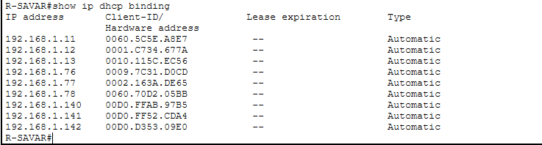
Figure 8: DHCP bindings assigned by R-SAVAR.
The output confirms that the router successfully assigned IP addresses to nine client devices across the three department VLANs. In VLAN 10 (Admin/IT), the addresses 192.168.1.11, 192.168.1.12 and 192.168.1.13 were leased. In VLAN 20 (Finance/HR), the addresses 192.168.1.76, 192.168.1.77 and 192.168.1.78 were leased. In VLAN 30 (Customer Service), the addresses 192.168.1.140, 192.168.1.141 and 192.168.1.142 were leased. All addresses shown in Figure 8 were automatically assigned by DHCP with an automatic lease type.

15. ROUTER INTERFACE VERIFICATION
The command show ip interface brief was executed on R-SAVAR to verify the status of the subinterfaces. The actual output is shown in Figure 9.
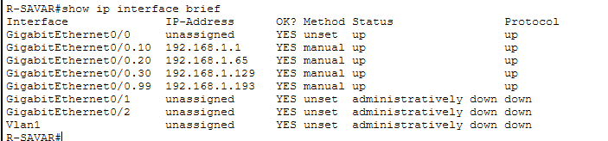
Figure 9: Router subinterface status on R-SAVAR.
Interface | IP Address | Status
G0/0.10 | 192.168.1.1 | up/up
G0/0.20 | 192.168.1.65 | up/up
G0/0.30 | 192.168.1.129 | up/up
G0/0.99 | 192.168.1.193 | up/up
The up/up status of every subinterface confirms that the Router-on-a-Stick configuration is operational and ready to route traffic between the department VLANs.

16. NETWORK TESTING
The ping command was used from various devices to verify connectivity across the network. The actual results obtained are described below.

16.1 Router to VLAN Gateways
Ping tests were carried out to the Finance/HR gateway (192.168.1.65) and the Customer Service gateway (192.168.1.129). Both tests returned a success rate of 100 percent, confirming that the router interfaces for these VLANs were reachable.

16.2 Router to Wireless Client
A ping test to the wireless client address 192.168.1.11 also returned a success rate of 100 percent, confirming communication between the router and the Admin/IT wireless client.

17. INTER-VLAN ROUTING VERIFICATION
Devices belonging to different VLANs were tested using the ping command to confirm that inter-VLAN routing through R-SAVAR was functioning correctly.
PC0, located in VLAN 10 (Admin/IT), was used to ping 192.168.1.76 (a Finance/HR host in VLAN 20) and 192.168.1.140 (a Customer Service host in VLAN 30). The actual results are shown in Figure 10.
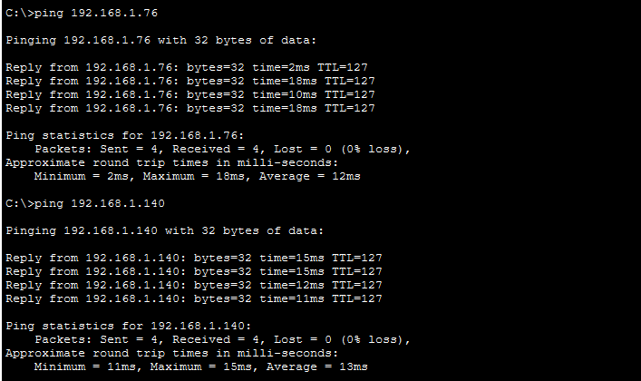
Figure 10: Inter-VLAN connectivity test from PC0 (VLAN 10) to VLAN 20 and VLAN 30 hosts.
Both ping tests in Figure 10 completed with 4 packets sent, 4 received and 0 lost, confirming a 100 percent success rate and successful inter-VLAN routing between VLAN 10, VLAN 20 and VLAN 30.
Laptop1, located in VLAN 20 (Finance/HR), was used to ping 192.168.1.129 (the VLAN 30 gateway) and 192.168.1.1 (the VLAN 10 gateway). The actual results are shown in Figure 11.
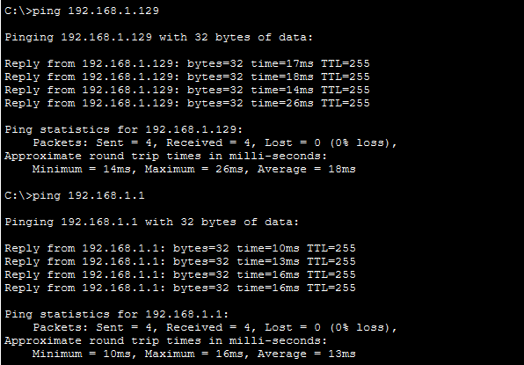
Figure 11: Inter-VLAN connectivity test from Laptop1 (VLAN 20) to the VLAN 30 and VLAN 10 gateways.
Both ping tests in Figure 11 also completed with a 100 percent success rate. These results confirm that the router successfully forwards traffic between the Admin/IT, Finance/HR and Customer Service VLANs through the Router-on-a-Stick configuration.

18. FINAL VERIFICATION SUMMARY
Table 5 summarizes the verification tests performed during the project, based on the actual results obtained.
Test | Result
VLAN creation | Successful
Access port assignment | Successful
Trunk configuration | Successful
Native VLAN 99 | Successful
Router subinterfaces | Successful
DHCP | Successful
Wired client addressing | Successful
Wireless connectivity | Successful
Inter-VLAN routing | Successful
Ping verification | Successful

19. SECURITY CONSIDERATIONS
The following basic security measures were applied in this project:
- VLAN segmentation separates departments logically, limiting broadcast traffic and unnecessary visibility between departments.
- WPA2-PSK encryption is used on every wireless access point to secure wireless connections.
- DHCP provides controlled and consistent automatic addressing across the network.
- The native VLAN (VLAN 99) is kept separate from the department VLANs on the trunk link.
- Inter-VLAN communication is centrally handled by the router, allowing traffic between departments to be monitored and controlled at a single point.
No advanced security features such as access control lists, port security or firewall rules were configured in this project, as these were outside the defined scope.

20. TROUBLESHOOTING AND RESOLUTION
During implementation, an issue was encountered with the Admin/IT wireless laptop. Although the laptop received an IP address from DHCP, its Default Gateway field initially showed 0.0.0.0. As a result, the laptop could not reach gateways of other VLANs, even though it could obtain an address on its own subnet.
The cause of the issue was that the DHCP pool ADMIN_IT_POOL did not initially contain the default-router statement, so the router was not advertising a default gateway to clients in that pool.
The issue was corrected by adding the missing default-router command to the ADMIN_IT_POOL configuration:
configure terminal
ip dhcp pool ADMIN_IT_POOL
default-router 192.168.1.1
exit
end
After this correction, the client renewed its DHCP configuration and received the correct default gateway address of 192.168.1.1, which restored inter-VLAN communication from the Admin/IT wireless client to the rest of the network.

21. CONCLUSION
The XYZ Company Savar Branch network was successfully designed and implemented in Cisco Packet Tracer. The final network provides department-based VLAN segmentation for Admin/IT, Finance/HR and Customer Service, along with a separate native/management VLAN.
Both wired and wireless connectivity were implemented for all departments, with automatic DHCP addressing configured for each department VLAN. Inter-VLAN routing was achieved using the Router-on-a-Stick method, and WPA2 wireless security was applied to all access points. Communication testing using ping confirmed successful connectivity within and between VLANs.
It should be noted that no Internet or WAN connection was configured in this project, and the network operates as a self-contained local area network for the Savar branch.

22. REFERENCES
- Cisco Networking Academy / Cisco Packet Tracer documentation.
- Cisco IOS command reference documentation.
- Course lecture materials.

APPENDIX A: COMPLETE SWITCH CONFIGURATION
enable
configure terminal
hostname SW-SAVAR

vlan 10
name ADMIN_IT
exit

vlan 20
name FINANCE_HR
exit

vlan 30
name CUSTSERVICE
exit

vlan 99
name MGMT_NATIVE
exit

interface gigabitEthernet 0/1
switchport mode trunk
switchport trunk native vlan 99
exit

interface range fastEthernet 0/2 - 3
switchport mode access
switchport access vlan 10
exit

interface range fastEthernet 0/4 - 5
switchport mode access
switchport access vlan 20
exit

interface range fastEthernet 0/6 - 7
switchport mode access
switchport access vlan 30
exit

interface fastEthernet 0/10
switchport mode access
switchport access vlan 10
exit

interface fastEthernet 0/11
switchport mode access
switchport access vlan 20
exit

interface fastEthernet 0/12
switchport mode access
switchport access vlan 30
exit

end
copy running-config startup-config

APPENDIX B: COMPLETE FINAL ROUTER CONFIGURATION
enable
configure terminal
hostname R-SAVAR

interface gigabitEthernet 0/0
no shutdown
exit

interface gigabitEthernet 0/0.10
encapsulation dot1Q 10
ip address 192.168.1.1 255.255.255.192
exit

interface gigabitEthernet 0/0.20
encapsulation dot1Q 20
ip address 192.168.1.65 255.255.255.192
exit

interface gigabitEthernet 0/0.30
encapsulation dot1Q 30
ip address 192.168.1.129 255.255.255.192
exit

interface gigabitEthernet 0/0.99
encapsulation dot1Q 99 native
ip address 192.168.1.193 255.255.255.192
exit

ip dhcp excluded-address 192.168.1.1 192.168.1.10
ip dhcp excluded-address 192.168.1.65 192.168.1.75
ip dhcp excluded-address 192.168.1.129 192.168.1.139

ip dhcp pool ADMIN_IT_POOL
network 192.168.1.0 255.255.255.192
default-router 192.168.1.1
dns-server 8.8.8.8
exit

ip dhcp pool FINANCE_HR_POOL
network 192.168.1.64 255.255.255.192
default-router 192.168.1.65
dns-server 8.8.8.8
exit

ip dhcp pool CUSTSERVICE_POOL
network 192.168.1.128 255.255.255.192
default-router 192.168.1.129
dns-server 8.8.8.8
exit

end
copy running-config startup-config

APPENDIX C: VERIFICATION COMMANDS
The following commands were used to verify the network configuration.

Switch
show vlan brief
show interfaces trunk
show interfaces gigabitEthernet 0/1 switchport
show vlan brief verifies VLAN creation and port membership. show interfaces trunk verifies trunk status and allowed VLANs. show interfaces gigabitEthernet 0/1 switchport verifies the switchport mode and native VLAN of the trunk interface.

Router
show ip interface brief
show ip dhcp pool
show ip dhcp binding
show ip interface brief verifies the status of each subinterface. show ip dhcp pool displays the configuration of each DHCP pool. show ip dhcp binding verifies the IP addresses leased to client devices.

Client
ipconfig
ping 192.168.1.1
ping 192.168.1.65
ping 192.168.1.129
ipconfig displays the IP configuration of the client. The ping commands verify reachability of the gateway addresses of each department VLAN from a client device.

